The Greatest Time In History

Can you imagine
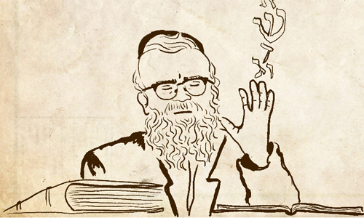

That the Creator of the entire world would come and talk – To You?!

Well it really happened! 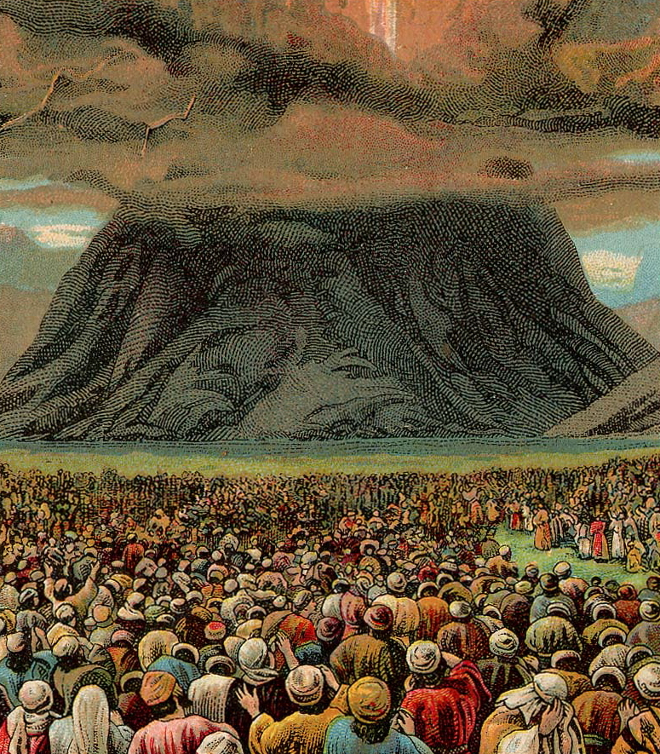

There was a single moment in which Hashem spoke – to every single Jew - in fact you were there.

Firstly it says every Jewish soul was there, but also the Kabbalists teach us that our generation is a reincarnation (which means, first a soul is born in heaven, then comes into a body on earth, but then after passing goes back to heaven, but then comes back) and we are the same generation that left Egypt – so not only was your soul there but so was your body.
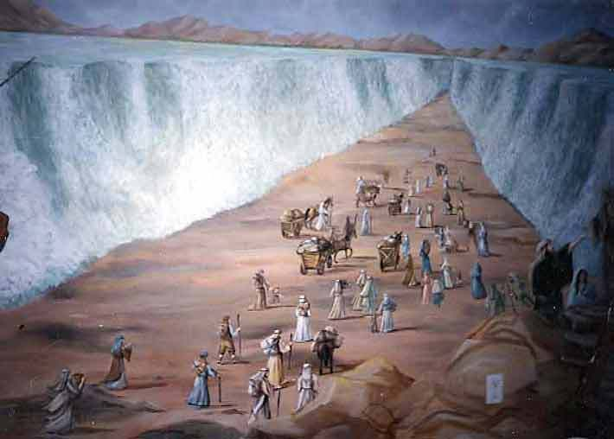
Here is what Hashem said (in modern English)

“Pay attention please – I am your personal Hashem who personally took you out of Egypt (this is the most important Mitzvah of the Torah, for it teaches us to never be afraid, for no matter how bad a person or group can be, Hashem can and will save us.)
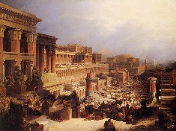
Don’t think there is any other power in the world – don’t bow to anyone or anything (only follow Hashem.)

Don’t say Hashem’s name for no reason (for we must have the utmost respect, for if we don’t, we will not take Hashem seriously.)

Keep the Shabbos (Once a week, we remind ourselves everything that is good; everything that is holy; we remember that in six days Hashem made everything and made Shabbos a holy, special, learning, and relaxing, refreshing day.)
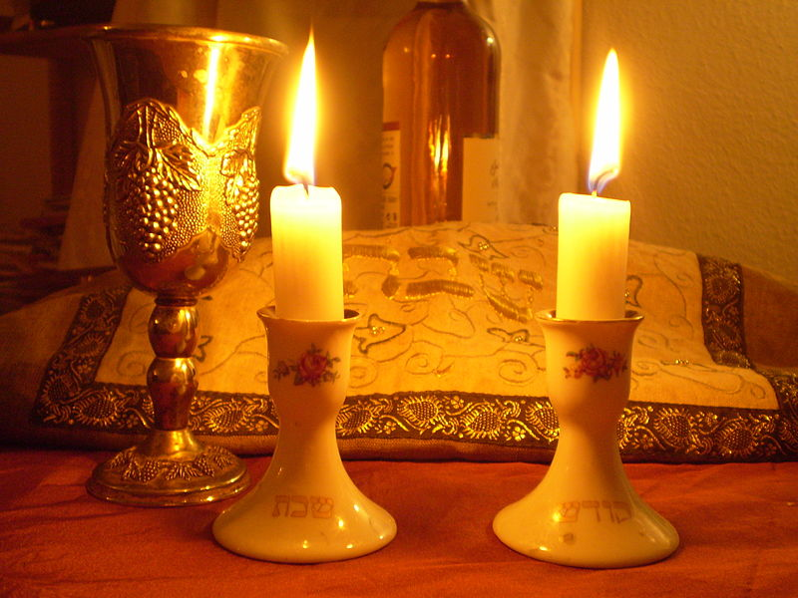
Honor your father and mother (It is easy to forget what you owe because you are so busy remembering what you are owed! – without your parents you wouldn’t be here! – they do so much and love you so much! – you must always be happy to listen to them!)

Do not kill (Thank G-d we see this as obvious, but sometimes when people are angry they are ready to do terrible things, so maybe number one we should never get angry, or if we do we should right away calm down.)

Do not commit adultery (Hashem decided that the most beautiful way to live is for a man and woman to fall in love and get married - when two people do this they make a special bond that each one is devoted exclusively to the other.)

Do not steal (never take anything from anyone without their permission.)


Do not lie.

Do not want anything that someone else has which is unique – for example, if they have a car and you can buy it, that’s o.k., but if they have something you can’t have like their home, their wife, a painting (as there is only one original) make sure you understand that this is Hashem’s gift to them – and Hashem has gifts that you will have.


Make sure to be in the Shul this Wednesday to hear the giving of the Torah – Do you know every year Hashem once again (as the Baal Korah, reader of the Torah says the Ten Commandments) gives it to us again – for remember Hashem is talking directly and especially to you!!!!

